**Bank Loan Project (SQL Queries):-**

KPIs:-

1.Total Loan Applicants-

select count(id) from financial_loan;



2. MTD Total loan applicants:-

select count(id) as MTD_Loan_applicants from financial_loan

where month(issue_date)=month((select max(issue_date) from financial_loan))

and year(issue_date)=year((select max(issue_date) from financial_loan));



3.MOM Loan applicants:-

select ((MTD_Loan_applicants-PMTD_Loan_applicants)/PMTD_Loan_applicants)*100 as MOM_LOan_applicants

from (select

(select count(id) from financial_loan

where month(issue_date)=month((select max(issue_date) from financial_loan))

and year(issue_date)=year((select max(issue_date) from financial_loan))) as MTD_Loan_applicants,

(select count(id) as PMTD_Loan_applicants from financial_loan

where month(issue_date)=month((select max(issue_date) from financial_loan))-1

and year(issue_date)=year((select max(issue_date) from financial_loan))) as PMTD_Loan_applicants

) as x;



4.Total amount funded:-

Select sum(loan_amount) from financial_loan;



5. MTD Total amount funded:-

select sum(loan_amount) as MTD_Loan_amount

from financial_loan

where month(issue_date)=month((select max(issue_date) from financial_loan))

and year(issue_date)=year((select max(issue_date) from financial_loan));



6.MoM amount funded:-

select ((MTD_Loan_amount-PMTD_Loan_amount)/PMTD_Loan_amount)*100 as MOM_Loan_amount

from (select

(select sum(loan_amount) as MTD_Loan_amount

from financial_loan

where month(issue_date)=month((select max(issue_date) from financial_loan))

and year(issue_date)=year((select max(issue_date) from financial_loan))) as MTD_Loan_amount,

(select sum(loan_amount) as PMTD_Loan_amount

from financial_loan

where month(issue_date)=month((select max(issue_date) from financial_loan))-1

and year(issue_date)=year((select max(issue_date) from financial_loan))) as PMTD_Loan_amount

)as X;



7. Total amount received:-

select sum(total_payment) as Total_amount_recieved from financial_loan;



8.MTD Total amount received:-

select sum(total_payment) as MTD_total_amount_recieved

from financial_loan

where month(issue_date)=month((select max(issue_date) from financial_loan))

and year(issue_date)=year((select max(issue_date) from financial_loan));



9.MoM total amount received:-

select ((MTD_total_amount_recieved-PMTD_total_amount_recieved)/PMTD_total_amount_recieved)*100 as MOM_Amount_recieved

from (select

(select sum(total_payment) as MTD_total_amount_recieved

from financial_loan

where month(issue_date)=month((select max(issue_date) from financial_loan))

and year(issue_date)=year((select max(issue_date) from financial_loan))) as MTD_total_amount_recieved,

(select sum(total_payment)

from financial_loan

where month(issue_date)=month((select max(issue_date) from financial_loan))-1

and year(issue_date)=year((select max(issue_date) from financial_loan))) as PMTD_total_amount_recieved

)as X;



10.Average interest rate:-

select avg(int_rate)*100 as average_interest_rate from financial_loan;



11.MTD average interest:-

select avg(int_rate)*100 as average_interest_rate

from financial_loan

where month(issue_date)=month((select max(issue_date) from financial_loan))

and year(issue_date)=year((select max(issue_date) from financial_loan));



12.MoM average interest:-

select ((MTD_average_interest_rate-PMTD_average_interest_rate)/PMTD_average_interest_rate)*100 as MOM_average_interest

from (select

(select avg(int_rate)

from financial_loan

where month(issue_date)=month((select max(issue_date) from financial_loan))

and year(issue_date)=year((select max(issue_date) from financial_loan))) as MTD_average_interest_rate,

(select avg(int_rate)

from financial_loan

where month(issue_date)=month((select max(issue_date) from financial_loan))-1

and year(issue_date)=year((select max(issue_date) from financial_loan))) as PMTD_average_interest_rate

)as X;



13.Average dTI:-

select avg(dti) as average_dti from financial_loan;



14.MTD_average_dti:-

select avg(dti) as MTD_average_dti

from financial_loan

where month(issue_date)=month((select max(issue_date) from financial_loan))

and year(issue_date)=year((select max(issue_date) from financial_loan));



15.Good loan applicants:-

select count(id) as good_loan

from financial_loan

where loan_status in ("Fully Paid","Current");



16.Bad Loan applicants:-

select count(id) as bad_loan

from financial_loan

where loan_status in ("Charged off");



17.Good loan amount:-

select sum(loan_amount) as good_loan_amount

from financial_loan

where loan_status in ("Fully Paid","Current");



18.Bad loan amount:-

select sum(loan_amount) as bad_loan_amount

from financial_loan

where loan_status in ("Charged off");



19.Good loan amount received:-

select sum(total_payment) as good_loan_amount_recieved

from financial_loan

where loan_status in ("Fully Paid","Current");



20.Bad loan amount received:-

select sum(loan_amount) as bad_loan_amount

from financial_loan

where loan_status in ("Charged off");



21.Good loan percentage:-

select

(count(case when loan_status in ("Fully Paid","Current") then id end)*100)/

count(id) as good_loan_percentage

from financial_loan;



22.Bad loan percentage:-

select

(count(case when loan_status in ("Charged off") then id end)*100)/

count(id) as bad_loan_percentage

from financial_loan;



23.Loan status:-

select

loan_status,

count(id) as total_loan_applicants,

sum(loan_amount) as total_loan_amount,

sum(total_payment) as total_amount_recieved,

avg(int_rate*100) as interest_rate,

avg(dti*100) as average_dti

from financial_loan

group by loan_status;

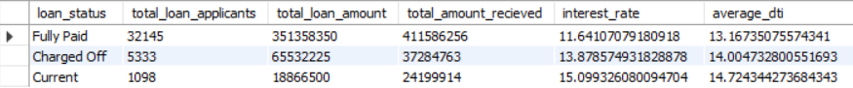

24.MTD Loan status:-

select

loan_status,

sum(loan_amount) as MTD_total_loan_amount,

sum(total_payment) as MTD_total_amount_recieved

from

financial_loan

where month(issue_date)=month((select max(issue_date) from financial_loan))

and year(issue_date)=year((select max(issue_date) from financial_loan))

group by

loan_status;

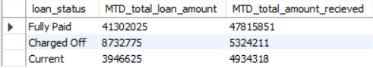

**Month wise trends:-**

select

MONTH(issue_date),

monthname(issue_date),

count(id) as total_loan_applicants,

sum(loan_amount) as total_loan_amount,

sum(total_payment) as total_amount_recieved

from

financial_loan

group by

MONTH(issue_date),monthname(issue_date)

order by

MONTH(issue_date);

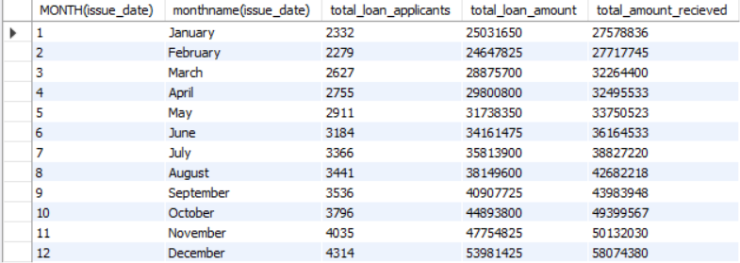

**Regional wise trends:-**

select

address_state,

count(id) as total_loan_applicants,

sum(loan_amount) as total_loan_amount,

sum(total_payment) as total_amount_recieved

from

financial_loan

group by

address_state

order by

sum(loan_amount) desc;

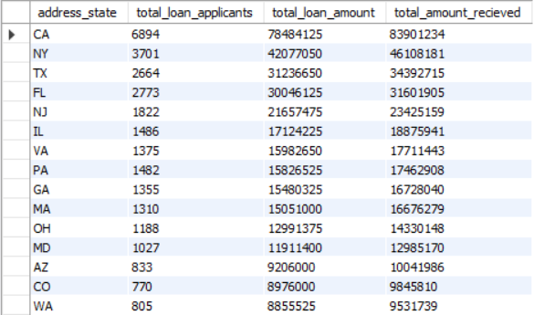

**Loan term analysis:-**

select

term,

count(id) as total_loan_applicants,

sum(loan_amount) as total_loan_amount,

sum(total_payment) as total_amount_recieved

from

financial_loan

group by

term

order by

sum(loan_amount);

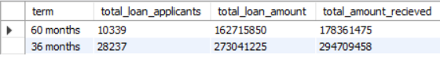

**Employee length analysis:-**

select

emp_length,

count(id) as total_loan_applicants,

sum(loan_amount) as total_loan_amount,

sum(total_payment) as total_amount_recieved

from

financial_loan

group by

emp_length

order by

emp_length;

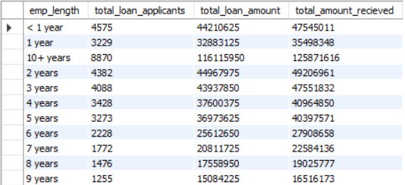

**Loan Purpose Breakdown:-**

select

purpose,

count(id) as total_loan_applicants,

sum(loan_amount) as total_loan_amount,

sum(total_payment) as total_amount_recieved

from

financial_loan

group by

purpose

order by

sum(loan_amount);

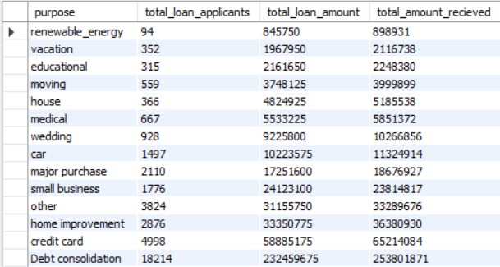

**Home ownership dependencies:-**

select

home_ownership,

count(id) as total_loan_applicants,

sum(loan_amount) as total_loan_amount,

sum(total_payment) as total_amount_recieved

from

financial_loan

group by

home_ownership

order by

sum(loan_amount);

